A

Mini Project On

#### HEART DISEASE PREDICTION USING MACHINE LEARNING

(Submitted in partial fulfillment of the requirements for the award of Degree)

BACHELOR OF TECHNOLOGY

In

COMPUTER SCIENCE AND ENGINEERING (AI&ML)

By

**M.KARISMA (207R1A66F7)**

**P.SAI TEJA (207R1A66G6)**

**A.PRAVEEN (207R1A66C4)**

Under the Guidance of

**Mrs. G. Parvati Devi**

(Assistant Professor)

##### **DEPARTMENT OF COMPUTER SCIENCE AND ENGINEERING (AI&ML)**

**CMR TECHNICAL CAMPUS UGC AUTONOMOUS**

(Accredited by NAAC, NBA, Permanently Affiliated to JNTUH, Approved by AICTE, New Delhi) Recognized Under Section 2(f) & 12(B) of the UGCAct.1956, Kandlakoya (V), Medchal Road, Hyderabad-501401. **2020-2024**

**DEPARTMENT OF COMPUTER SCIENCE AND ENGINEERING (AI&ML)**



#### CERTIFICATE

This is to certify that the project entitled **“ HEART DISEASE PREDICTION USING MACHINE LEARNING ”** being submitted by **M.KARISMA (207R1A66F7), P.SAI TEJA (207R1A66G6) & A.PRAVEEN (207R1A66C4)** in partial fulfillment of the requirements for the award of the degree of B.Tech in Computer Science and Engineering (AI&ML) to the Jawaharlal Nehru Technological University Hyderabad, is a record of bonafide work carried out by them under our guidance and supervision during the year 2022-23.

The results embodied in this thesis have not been submitted to any other University or Institute for the award of any degree or diploma.

**Mrs. G. Parvathi Devi Dr. S Rao Chintalapudi**

(Assistant Professor ) HOD CSE(AI&ML)

INTERNAL GUIDE

**EXTERNAL EXAMINER**

**Submitted for viva voice Examination held on** _______________

**ACKNOWLEDGEMENT**

Apart from the efforts of us, the success of any project depends largely on the encouragement and guidelines of many others. We take this opportunity to express our gratitude to the people who have been instrumental in the successful completion of this project.

We take this opportunity to express my profound gratitude and deep regard to my guide **Mrs. G. Parvathi Devi,** Assistant Professor for his exemplary guidance, monitoring and constant encouragement throughout the project work. The blessing, help and guidance given by him shall carry us a long way in the journey of life on which we are about to embark.

We also take this opportunity to express a deep sense of gratitude to the Project Review Committee (PRC) **Dr. G. Vinoda Reddy, Dr. K. Mahesh, Md. Hafeena & D. Babu Rao** for their cordial support, valuable information and guidance, which helped us in completing this task through various stages.

We are also thankful to **Dr. S Rao Chintalapudi,** Head, Department of Computer Science and Engineering (AI&ML) for providing encouragement and support for completing this project successfully.

We are obliged to **Dr. A. Raji Reddy,** Director for being cooperative throughout the course of this project. We also express our sincere gratitude to Sri. **Ch. Gopal Reddy,** Chairman for providing excellent infrastructure and a nice atmosphere throughout the course of this project.

The guidance and support received from all the members of **CMR Technical Campus** who contributed to the completion of the project. We are grateful for their constant support and help.

Finally, we would like to take this opportunity to thank our family for their constant encouragement, without which this assignment would not be completed. We sincerely acknowledge and thank all those who gave support directly and indirectly in the completion of this project.

###### **M.KARISMA (207R1A66F7)**

**P.SAI TEJA (207R1A66G6)**

**A.PRAVEEN (207R1A66C4)**

**ABSTRACT**

The heart is the most essential or important part of our body. The heart is used to maintain and conjugate blood in our body. There are many cases around the world related to heart disease. People lead to death from heart disease. Various symptoms like excessive breathing, fast heart rate, cholesterol, blood pressure, sudden rise in temperature, and also due to depression induced on heart by exercise etc. are some of the symptoms mentioned in the dataset. The medical profession has found a huge amount of data.

This paper introduces the idea of ​​predicting heart disease by machine learning algorithms. Here we will use different machine learning algorithms like support vector classifier, random forest, naïve bayes, decision tree and logistic regression. The algorithms used are based on characteristics and to predict heart disease. This article uses different machine learning algorithms to compare the accuracy between them. This machine learning model accurately predicts the heart attack based on the stated symptoms so that the user can easily find out the heart condition.

**LIST OF FIGURES/TABLES**

|  |  |  |
| --- | --- | --- |
| FIGURE NO | FIGURE NAME | PAGE NO |
| Figure 3.1 | Project Architecture for  Heart Disease  Prediction Using  Machine Learning | 10 |
| Figure 3.2 | Use Case Diagram for  Heart Disease Prediction  Using Machine Learning | 11 |
| Figure 3.3 | Class Diagram for  Heart Disease Prediction  Using Machine Learning | 12 |
| Figure 3.4 | Sequence diagram for  Heart Disease Prediction  Using Machine Learning | 13 |
| Figure 3.5 | Activity diagram for  Heart Disease Prediction  Using Machine Learning | 14 |

**LIST OF SCREENSHOTS**

|  |  |  |
| --- | --- | --- |
| SCREENSHOT NO. | SCREENSHOT NAME | PAGE NO. |
| Screenshot 5.1 | Main Page | 24 |
| Screenshot 5.2 | User Register Page | 24 |
| Screenshot 5.3 | User Login Page | 25 |
| Screenshot 5.4 | Taking inputs from user Page | 25 |
| Screenshot 5.5 | Displays Result Page | 26 |

**TABLE OF CONTENTS**

**ABSTRACT** i

LIST OF FIGURES ii

LIST OF SCREENSHOTS iii

1. INTRODUCTION 1
   1. PROJECT SCOPE 1
   2. PROJECT PURPOSE 1
   3. PROJECT FEATURES 1
2. SYSTEM ANALYSIS 3
   1. PROBLEM DEFINITION 4
   2. EXISTING SYSTEM 4
      1. LIMITATIONS OF THE EXISTING SYSTEM 4
   3. PROPOSED SYSTEM 5
      1. ADVANTAGES OF PROPOSED SYSTEM 5
   4. FEASIBILITY STUDY 6
      1. ECONOMIC FEASIBILITY 6
      2. TECHNICAL FEASIBILITY 7
      3. SOCIAL FEASIBILITY 7
   5. HARDWARE & SOFTWARE REQUIREMENTS 7
      1. HARDWARE REQUIREMENTS 7
      2. SOFTWARE REQUIREMENTS 8
3. ARCHITECTURE 9
   1. PROJECT ARCHITECTURE 10
   2. DESCRIPTION 10
   3. USE CASE DIAGRAM 11
   4. CLASS DIAGRAM 12
   5. SEQUENCE DIAGRAM 13
   6. ACTIVITY DIAGRAM 14
4. IMPLEMENTATION 15
   1. SAMPLE CODE 16
5. SCREENSHOTS 23
6. TESTING 27
   1. INTRODUCTION TO TESTING 28
   2. TYPES OF TESTING 28
      1. UNIT TESTING 28
      2. INTEGRATION TESTING 29
      3. FUNCTIONAL TESTING 29
   3. TEST CASES 30
      1. CLASSIFICATION 30
7. CONCLUSION & FUTURE SCOPE 32
   1. PROJECT CONCLUSION 32
   2. FUTURE SCOPE 32
8. REFERENCES 33
   1. REFERENCES 34
   2. GITHUB LINK 34
9. **INTRODUCTION**

#### INTRODUCTION

##### **PROJECT SCOPE**

The aim of this project is to develop a web platform that can predict disease occurrences based on various symptoms. The consumer will search for diseases based on their probabilistic figures by selecting different symptoms.

##### **PROJECT PURPOSE**

There are several methods for disease prediction. However, heart-related diseases have been studied, and a risk level has been calculated. However, such methods are not commonly used for disease prediction in general. As a result, the smart healthcare system aids in the prediction of general diseases. In certain cases, you or a family member may need urgent medical assistance, but physicians are unavailable due to unforeseen circumstances, or we may be unable to locate the appropriate doctor for the care. To address this problem, we will attempt to incorporate an online intelligent Smart Healthcare System in this project. It's a web-based program that allows patients to get immediate advice about their health problems.

##### **PROJECT FEATURES**

The heart disease prediction project using the random forest algorithm involves several key features. Firstly, a comprehensive and reliable dataset is collected, containing relevant features and a target variable indicating the presence or absence of heart disease. The dataset is then preprocessed by handling missing values, outliers, and inconsistencies, and split into training and testing subsets. Feature selection techniques are applied to identify the most significant features for predicting heart disease. The random forest algorithm is implemented using a suitable programming language or machine learning framework, with hyperparameters configured such as the number of decision trees and tree depth. Cross-validation techniques, such as k-fold cross-validation, are used to assess the model's performance and avoid overfitting. The model is trained on the training subset and evaluated on the testing subset using appropriate

evaluation metrics. Hyperparameter tuning is performed to optimize the model's performance. Feature importance analysis is conducted to understand the contribution of each feature in predicting heart disease. Methods for interpreting the model's predictions are developed, such as feature importance plots or SHAP values. Finally, the model is deployed and integrated into a suitable environment, ensuring compliance with ethical considerations and privacy guidelines.

## **2.SYSTEM ANALYSIS**

##### **SYSTEM ANALYSIS**

**SYSTEM ANALYSIS**

System Analysis is the important phase in the system development process. The System is studied to the minute details and analyzed. The system analyst plays an important role of an interrogator and dwells deep into the working of the present system. In analysis, a detailed study of these operations performed by the system and their relationships within and outside the system is done. A key question considered here is, “what must be done to solve the problem?” The system is viewed as a whole and the inputs to the system are identified. Once analysis is completed the analyst has a firm understanding of what is to be done.

##### **PROBLEM DEFINITION**

The general statement for Heart Disease prediction is it involves using Machine Learning algorithm to predict the disease risk associated with investing in a particular condition.

##### **EXISTING SYSTEM**

In existing system used Different supervised machine learning algorithms i.e. Naive Bayes, Neural Network, along with weighted association Apriori algorithm. The data mining tool Weka 3.6.6 is used for experiment. Weka is a collection of machine learning algorithms for data mining tasks. AI used three main data mining techniques in their work for predicting heart disease namely Decision TreeNeural NetworksNaïve Bayes Classifier are used.

* + 1. **DISADVANTAGES OF EXISTING SYSTEM**

Following are the disadvantages of existing system:

* Independence assumption may not hold in real-world scenarios.
* Sensitivity to irrelevant or redundant features.
* Inability to handle missing values effectively.
* Limited expressive power compared to more complex algorithms.
* Assumption of feature independence may be violated.
* Lack of accurate probabilistic outputs.

##### **PROPOSED SYSTEM**

The proposed system utilizes the random forest algorithm for accurate heart disease prediction. It collects a reliable dataset, preprocesses it, and splits it into training and testing subsets. The random forest algorithm handles complex relationships and diverse feature types. The model is trained, evaluated using metrics like accuracy, and validated through cross-validation. Feature importance analysis provides insights into key risk factors. Model interpretability is emphasized through plots and values. The system is deployed while ensuring ethical considerations and privacy guidelines are followed. Overall, the proposed system offers accurate prediction, early detection, and support for decision-making in healthcare.

* + 1. **ADVANTAGES OF THE PROPOSED SYSTEM**
* Accurate prediction: The system improves heart disease prediction accuracy.
* Robust handling of data: It effectively handles complex and diverse datasets.
* Feature importance insights: The system identifies key risk factors for heart disease.
* Model interpretability: It provides transparent and understandable predictions.
* Early detection and intervention: Enables timely interventions for at-risk individuals.
* Practical deployment: The system can be easily implemented in healthcare settings.

##### **FEASIBILITY STUDY**

The feasibility of the project is analyzed in this phase and a business proposal is put forth with a very general plan for the project and some cost estimates. During system analysis the feasibility study of the proposed system is to be carried out. This is to ensure that the proposed system is not a burden to the company. Three key considerations involved in the feasibility analysis:

* Economic Feasibility
* Technical Feasibility
* Social Feasibility

###### **ECONOMIC FEASIBILITY**

The developing system must be justified by cost and benefit. Criteria to ensure that effort is concentrated on a project, which will give best, return at the earliest. One of the factors, which affect the development of a new system, is the cost it would require.

The following are some of the important financial questions asked during preliminary investigation:

* + - * The costs conduct a full system investigation.
      * The cost of the hardware and software.
      * The benefits in the form of reduced costs or fewer costly errors.

Since the system is developed as part of project work, there is no manual cost to spend for the proposed system. Also all the resources are already available, it give an indication that the system is economically possible for development.

###### **TECHNICAL FEASIBILITY**

This study is carried to check the technical feasibility, that is, the technical requirements of the system. Any system developed must not have a high demand on the available technical resources. The developed system must have a modest requirement, as only minimal or null changes are required for implementing this system.

###### **BEHAVIORAL FEASIBILITY**

This includes the following questions:

* + - * Is there sufficient support for the users?
      * Will the proposed system cause harm?

The project would be beneficial because it satisfies the objectives when developed and installed. All behavioral aspects are considered carefully and conclude that the project is behaviorally feasible

##### **HARDWARE & SOFTWARE REQUIREMENTS**

###### **HARDWARE REQUIREMENTS:**

Hardware interfaces specify the logical characteristics of each interface between the software product and the hardware components of the system. The following are some hardware requirements.

* PROCESSOR : i3 or above
* RAM : 4GB (min)
* HARD DISK : 20 GB
* KEYBOARD : Standard Windows Keyboard
* MOUSE : Two or Three Button Mouse
* MONITOR : SVGA

##### **SOFTWARE REQUIREMENTS:**

Software Requirements specifies the logical characteristics of each interface and software components of the system. The following are some software requirements,

* OPERATING SYSTEM : Windows 10
* CODE LANGUAGE : Python
* LIBRARIES : Numpy, pandas, Sklearn, Matplotlib
* FRONT-END : Python
* BACK-END : Django-ORM
* DESIGNING : HTML, CSS, JavaScript
* DATABASE : MySQL (WAMP Server).

**3. ARCHITECTURE**

##### **3.ARCHITECTURE**

##### **PROJECT ARCHITECTURE**

This project architecture shows the procedure followed for classification, starting from input to final prediction.

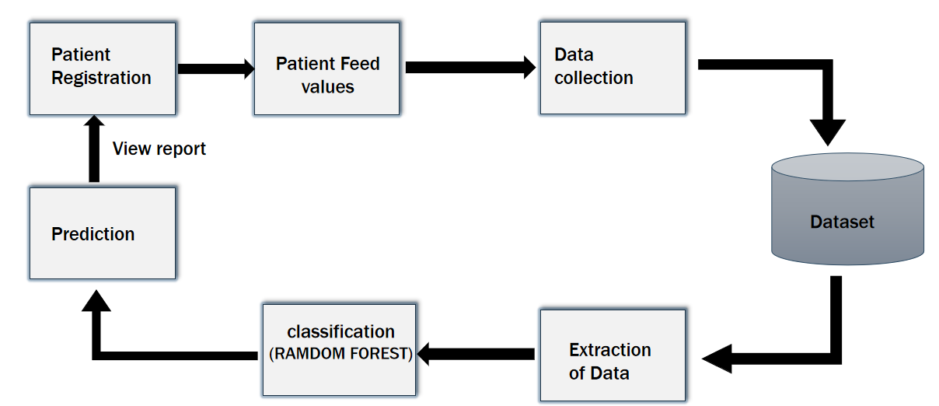

Figure 3.1: Project Architecture of Heart Disease Prediction Using Machine Learning.

###### **3.2 DESCRIPTION**

Initially the patient registers by providing certain parameters. That registered data is collected in a database by using machine learning techniques like data collection techniques and when he went to check about his health condition the collected values or data that has been stored in the database is been extracted by using some feature extraction techniques. When data is extracted, it under goes certain processes and therefore finally a disease is predicted and a report is generated. This is the overview of the heart disease prediction system using machine learning techniques.

#### USE CASE DIAGRAM

In the use case diagram, we have basically one actor who is the user in the trained model.

A Use Case diagram is a graphical depiction of a user's possible interactions with a system. A use case diagram shows various use cases and different types of users the system has. The use cases are represented by either circles or ellipses. The actors are often shown as stick figures.

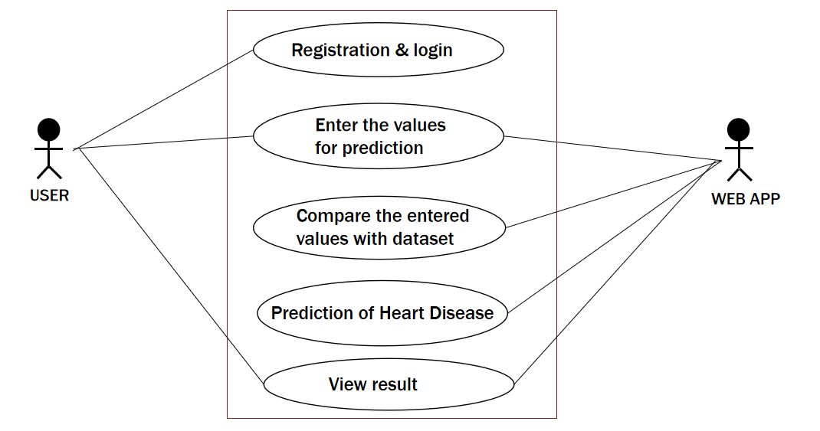

Figure 3.2: Use Case Diagram for Heart disease Prediction Using Machine Learning

##### **CLASS DIAGRAM**

Class diagram is a type of static structure diagram that describes the structure of a system by showing the system’s classes, their attributes, operations (or methods), and the relationships among objects.

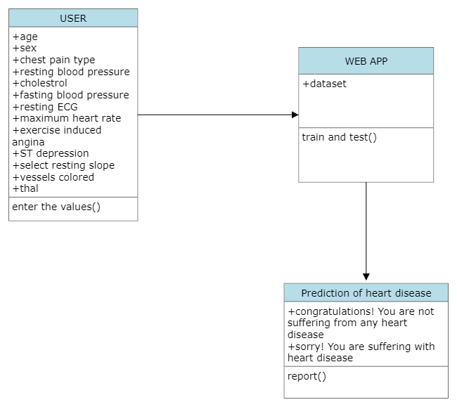

Figure 3.3: Class Diagram for Heart Disease Prediction Using Machine Learning

##### **SEQUENCE DIAGRAM**

A Sequence Diagram shows object interactions arranged in time sequence. It depicts the objects involved in the scenario and the sequence of messages exchanged between the objects needed to carry out the functionality of the scenario. Sequence diagrams are typically associated with use case realizations in the logical view of the system under development.

n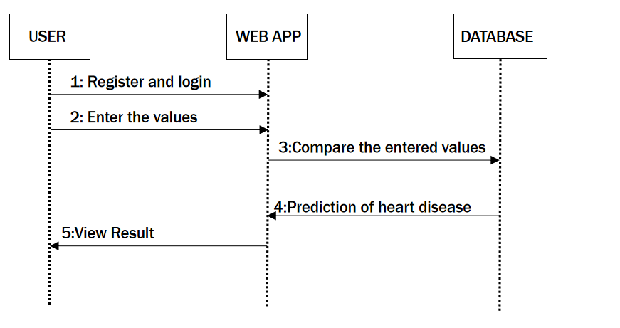

Figure 3.4: Sequence Diagram for Prediction Using Machine Learning

###### **ACTIVITY DIAGRAM**

Activity diagrams are graphical representations of workflows of stepwise activities and actions with support for choice, iteration and concurrency. They can also include elements showing the flow of data between activities through one or more data stores.

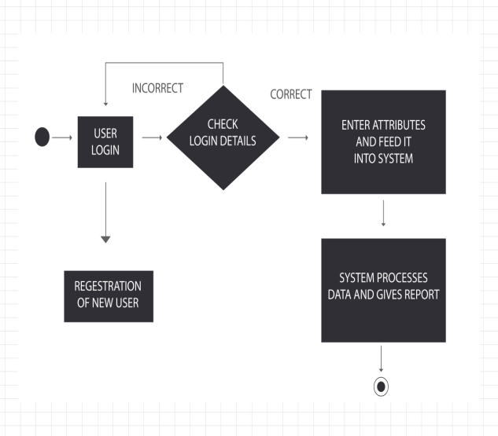

Figure 3.5: Activity Diagram for Heart Disease Prediction Using Machine Learning

**4. IMPLEMENTATION**

**4.1 SAMPLE CODE:**

#!/usr/bin/env python

"""Django's command-line utility for administrative tasks."""

import os

import sys

def main():

os.environ.setdefault('DJANGO_SETTINGS_MODULE', 'heartDiseasePrediction.settings')

try:

from django.core.management import execute_from_command_line

except ImportError as exc:

raise ImportError(

"Couldn't import Django. Are you sure it's installed and "

"available on your PYTHONPATH environment variable? Did you "

"forget to activate a virtual environment?"

) from exc

execute_from_command_line(sys.argv)

if _name_ == '_main_':

main()

from django.db import migrations, models

class Migration(migrations.Migration):

initial = True

dependencies = [

]

operations = [

migrations.CreateModel(

name='user',

fields=[

('id', models.AutoField(auto_created=True, primary_key=True, serialize=False, verbose_name='ID')),

('username', models.TextField()),

('password', models.TextField()),

],

),

migrations.CreateModel(

name='user_info',

fields=[

('id', models.AutoField(auto_created=True, primary_key=True, serialize=False, verbose_name='ID')),

('age', models.IntegerField()),

('sex', models.CharField(max_length=10)),

('chestPainType', models.TextField()),

('restingBloodPressure', models.IntegerField()),

('serumCholestrol', models.IntegerField()),

('fastingBloodSugar', models.BooleanField()),

('restingEcg', models.TextField()),

('maxHr', models.IntegerField()),

('BloodSugar', models.IntegerField()),

('stDpressionInduced', models.IntegerField()),

('ExerciseInducedAngina', models.CharField(max_length=50)),

('peakST', models.CharField(max_length=50)),

('NumberOfVessels', models.IntegerField()),

('thalassemia', models.CharField(max_length=50)),

],

),

]

import os

# Build paths inside the project like this: os.path.join(BASE_DIR, ...)

BASE_DIR = os.path.dirname(os.path.dirname(os.path.abspath(_file_)))

# Quick-start development settings - unsuitable for production

# See https://docs.djangoproject.com/en/3.0/howto/deployment/checklist/

# SECURITY WARNING: keep the secret key used in production secret!

SECRET_KEY = 'eujl9kwyqii2pw4=$gqe0=d_k%m9r19!bnds13cf$^cnzk78*p'

# SECURITY WARNING: don't run with debug turned on in production!

DEBUG = True

ALLOWED_HOSTS = []

# Application definition

INSTALLED_APPS = [

'django.contrib.admin',

'django.contrib.auth',

'django.contrib.contenttypes',

'django.contrib.sessions',

'django.contrib.messages',

'django.contrib.staticfiles',

]

MIDDLEWARE = [

'django.middleware.security.SecurityMiddleware',

'django.contrib.sessions.middleware.SessionMiddleware',

'django.middleware.common.CommonMiddleware',

'django.middleware.csrf.CsrfViewMiddleware',

'django.contrib.auth.middleware.AuthenticationMiddleware',

'django.contrib.messages.middleware.MessageMiddleware',

'django.middleware.clickjacking.XFrameOptionsMiddleware',

]

ROOT_URLCONF = 'heartDiseasePrediction.urls'

TEMPLATES = [

{

'BACKEND': 'django.template.backends.django.DjangoTemplates',

'DIRS': [],

'APP_DIRS': True,

'OPTIONS': {

'context_processors': [

'django.template.context_processors.debug',

'django.template.context_processors.request',

'django.contrib.auth.context_processors.auth',

'django.contrib.messages.context_processors.messages',

],

},

},

]

WSGI_APPLICATION = 'heartDiseasePrediction.wsgi.application'

# Database

# https://docs.djangoproject.com/en/3.0/ref/settings/#databases

DATABASES = {

'default': {

'ENGINE': 'django.db.backends.sqlite3',

'NAME': os.path.join(BASE_DIR, 'db.sqlite3'),

}

}

# Password validation

# https://docs.djangoproject.com/en/3.0/ref/settings/#auth-password-validators

AUTH_PASSWORD_VALIDATORS = [

{

'NAME': 'django.contrib.auth.password_validation.UserAttributeSimilarityValidator',

},

{

'NAME': 'django.contrib.auth.password_validation.MinimumLengthValidator',

},

{

'NAME': 'django.contrib.auth.password_validation.CommonPasswordValidator',

},

{

'NAME': 'django.contrib.auth.password_validation.NumericPasswordValidator',

},

]

# Internationalization

# https://docs.djangoproject.com/en/3.0/topics/i18n/

LANGUAGE_CODE = 'en-us'

TIME_ZONE = 'UTC'

USE_I18N = True

USE_L10N = True

USE_TZ = True

# Static files (CSS, JavaScript, Images)

# https://docs.djangoproject.com/en/3.0/howto/static-files/

# STATICFILES_DIRS = [os.path.join(BASE_DIR, "static")]

# STATIC_ROOT = ("path/to/static_root")

# STATIC_URL = '/static/'

STATIC_URL = '/static/'

STATICFILES_DIRS = (

os.path.join(BASE_DIR, 'static_root'),

)

STATIC_ROOT = os.path.join(BASE_DIR, 'static')

**5. SCREENSHOTS**

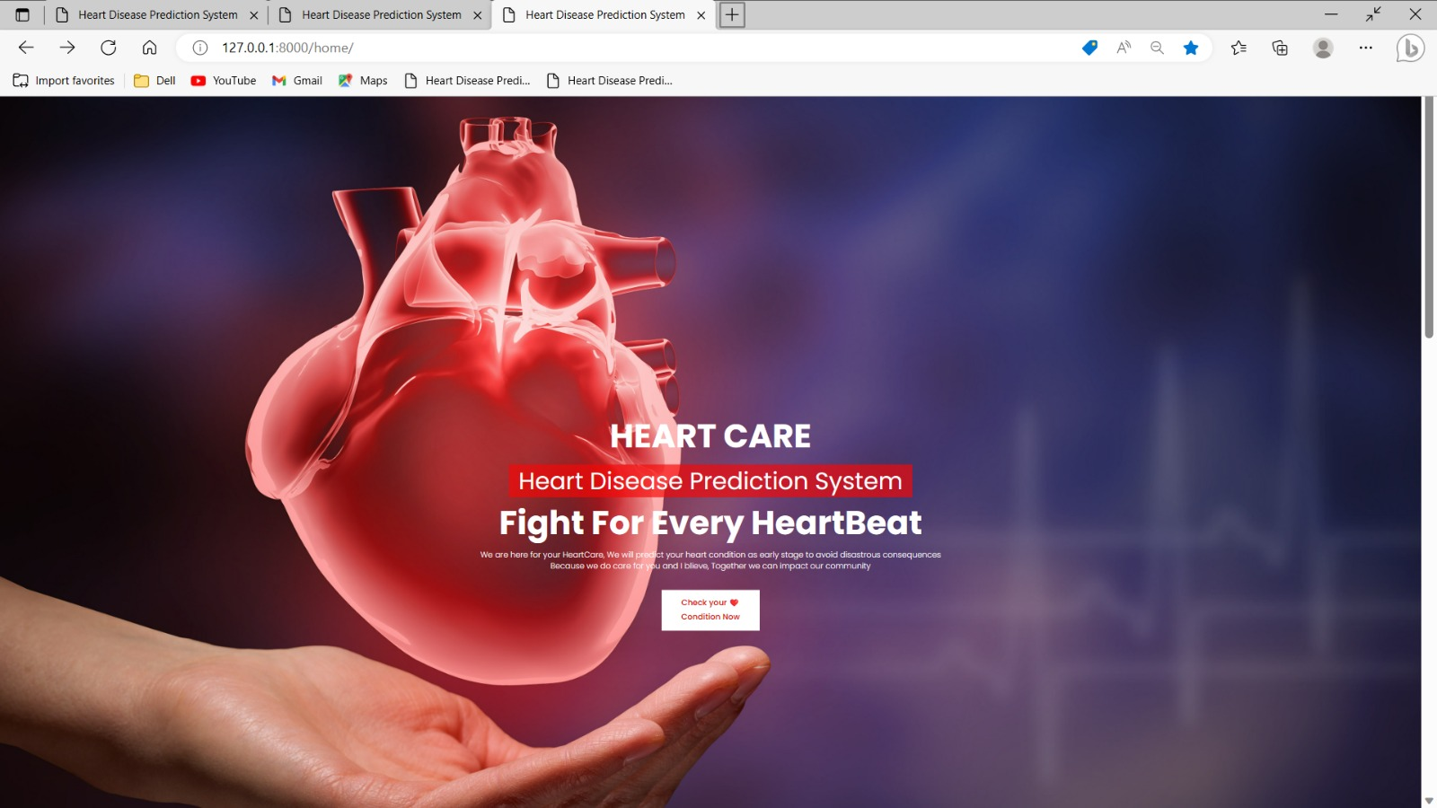

Screenshot 5.1:Main Page

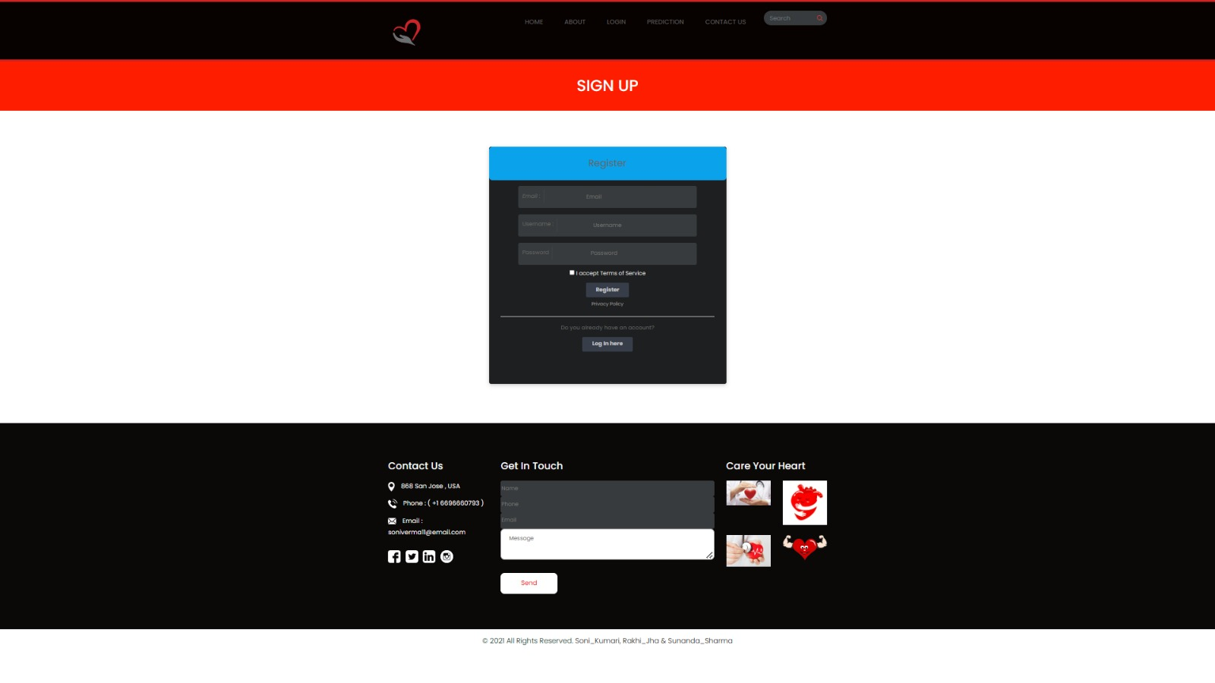

Screenshot 5.2: User Register Page

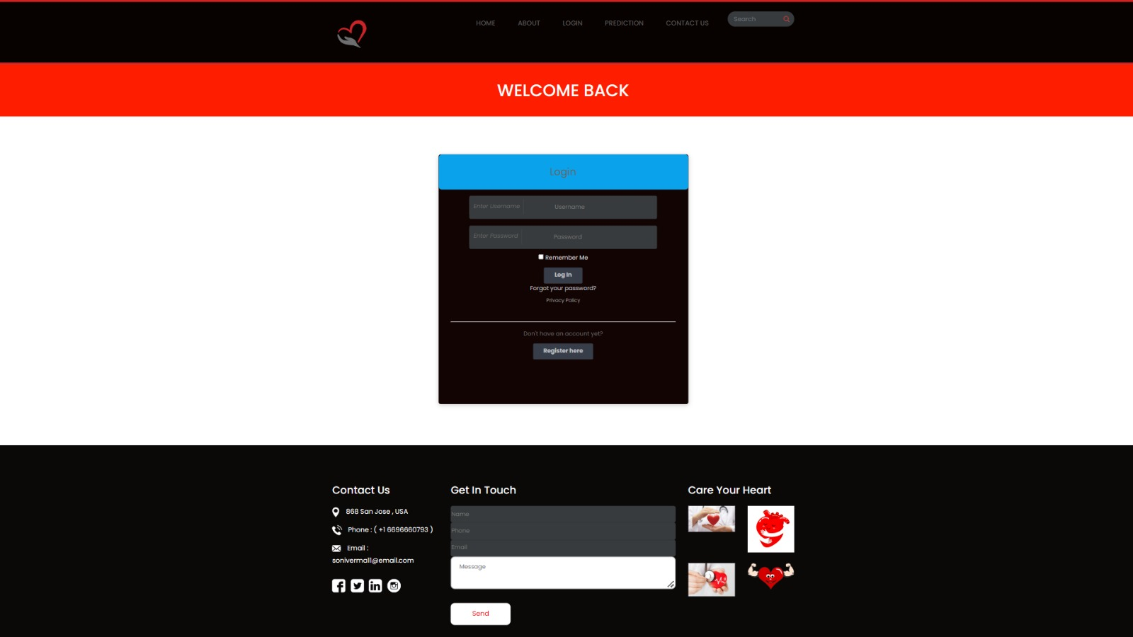

Screenshot 5.3: User Login Page

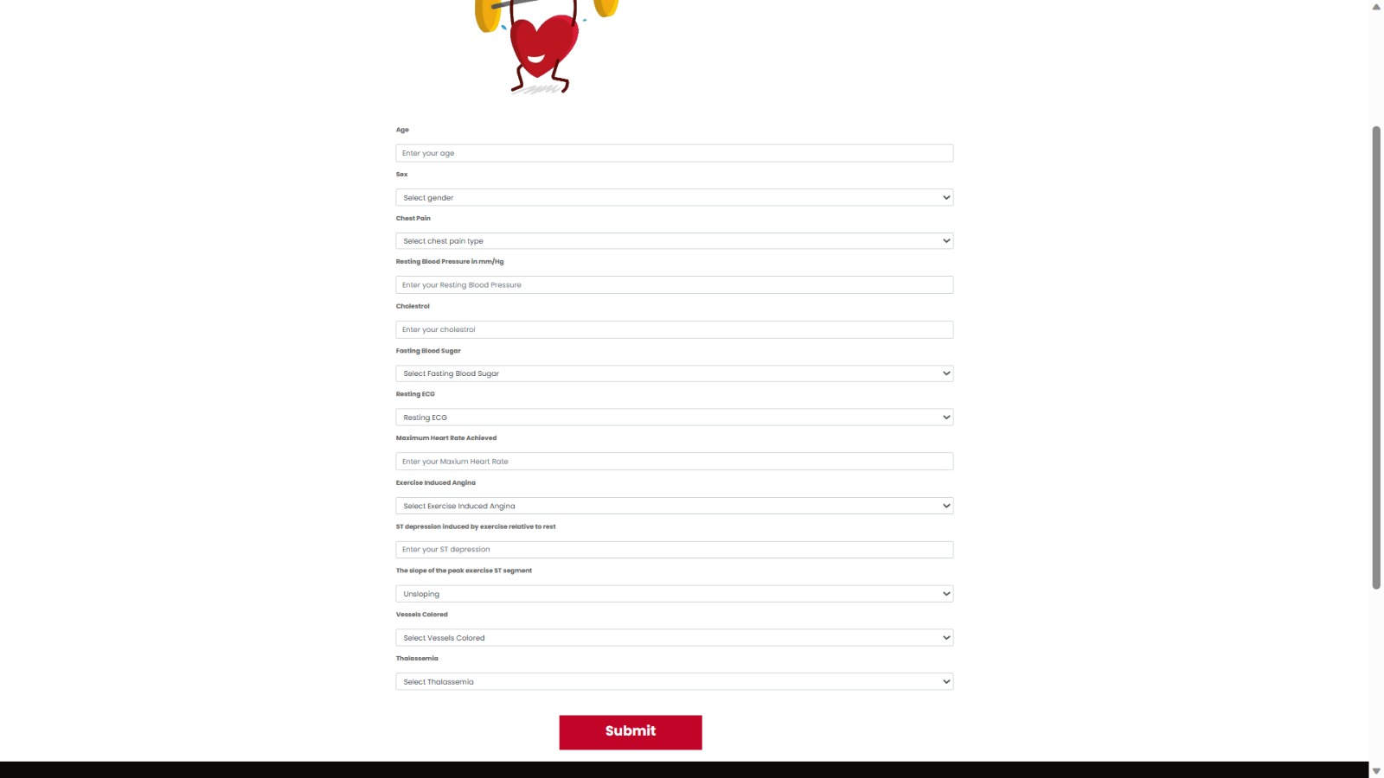

Screenshot 5.4: Taking inputs from user page

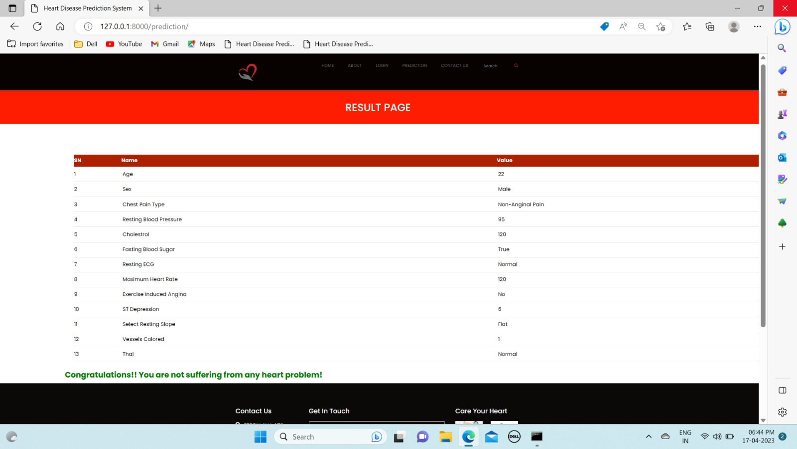

Screenshot 5.5: Displays Result Page

**6. TESTING**

#### 6. TESTING

##### **INTRODUCTION TO TESTING**

The purpose of testing is to discover errors. Testing is the process of trying to discover every conceivable fault or weakness in a work product. It provides a way to check the functionality of components, subassemblies, assemblies and/or a finished product. It is the process of exercising software with the intent of ensuring that the Software system meets its requirements and user expectations and does not fail in an unacceptable manner. There are various types of tests. Each test type addresses a specific testing requirement.

##### **TYPES OF TESTING**

###### **UNIT TESTING**

Unit testing involves the design of test cases that validate that the internal program logic is functioning properly, and that program inputs produce valid outputs. All decision branches and internal code flow should be validated. It is the testing of individual software units of the application.It is done after the completion of an individual unit before integration. This is a structural testing that relies on knowledge of its construction and is invasive. Unit tests perform basic tests at component level and test a specific business process, application and/or system configuration. Unit tests ensure that each unique path of a business process performs accurately to the documented specifications and contains clearly defined inputs and expected results.

###### **INTEGRATION TESTING**

Integration tests are designed to test integrated software components to determine if they actually run as one program. Integration tests demonstrate that although the components were individually satisfactory, as shown by successfully unit testing, the combination of components is correct and consistent. Integration testing is specifically aimed at exposing the problems that arise from the combination of components.

###### **FUNCTIONAL TESTING**

Functional tests provide systematic demonstrations that functions tested are available as specified by the business and technical requirements, system documentation, and user manuals.

Functional testing is centered on the following items:

Valid input : identified classes of valid input must be accepted.

Invalid input : identified classes of invalid input must be rejected.

Functions : identified functions must be exercised.

Output : identified classes of application outputs must be exercised.

Systems/Procedures: interfacing systems or procedures must be invoked. Organization and preparation of functional tests is focused on requirements, key functions, or special test cases

* 1. **TEST CASE**

###### **6.3.1CLASSIFICATION**

|  |  |  |  |  |
| --- | --- | --- | --- | --- |
| **Test case ID** | **Test case name** | **Purpose** | **Input** | **Output** |
| 1 | HEART DISEASE PREDICTION. | To predict the heart disease by taking specific inputs. | The patients or users will enter the values for prediction. | If the patient is having heart disease then the output will be “Sorry! You are suffering with heart disease” else the output will be “Congratulations! You are not suffering from any heart disease” |

**7.CONCLUSION**

#### 7.CONCLUSION & FUTURE SCOPE

#### 7.1PROJECT CONCLUSION

In Conclusion, the project has developed an accurate and interpretable system for heart disease prediction using the “Random Forest Algorithm”. The system identifies key risk factors, allowing for early detection and timely interventions. Its practical deployment ensures usability in healthcare settings while maintaining ethical considerations and privacy. Overall, this project contributes to improved patient outcomes and informed decision-making in heart disease prediction.

#### 7.2 FUTURE SCOPE

The project presents promising future scopes for advancement. By incorporating genetic and lifestyle factors, the accuracy of heart disease prediction can be enhanced. Integration with telemedicine platforms enables remote monitoring and consultations, expanding access to healthcare services. Predicting individual treatment responses allows for personalized treatment plans and improved outcomes. Stratifying patients based on risk categories optimizes resource allocation. Long-term follow-up capabilities assess intervention effectiveness and refine the prediction model. Integrating the system with digital health platforms and wearables enables real-time data collection and personalized risk assessments. Emphasizing explainable AI techniques enhances interpretability, fostering trust. Collaborating with institutions and organizations for data sharing and research improves system performance. These future scopes aim to improve accuracy, accessibility, and patient outcomes, advancing healthcare practices. By integrating additional data sources, refining models, and leveraging technology, the project contributes to personalized, remote, and proactive healthcare management. Fostering collaboration leads to a comprehensive understanding of heart disease and enhances prediction systems, ultimately improving patient care and outcomes.

**8.BIBLIOGRAPHY**

**8.1 REFERENCES**

[1]Avinash Golande, Pavan Kumar T, Heart Disease Prediction Using Effective Machine Learning Techniques, International Journal of Recent Technology and Engineering, Vol 8, pp.944-950,2019.

[2]T.Nagamani, S.Logeswari, B.Gomathy, Heart Disease Prediction using Data Mining with Mapreduce Algorithm, International Journal of Innovative Technology and Exploring Engineering (IJITEE) ISSN: 2278-3075, Volume-8 Issue-3, January 2019.

[3]Fahd Saleh Alotaibi, Implementation of Machine Learning Model to Predict Heart Failure Disease, (IJACSA) International Journal of Advanced Computer Science and Applications, Vol. 10, No. 6, 2019.

[4]Ashir Javeed, Shijie Zhou, Liao Yongjian , Iqbal Qasim , Adeeb Noor , and Redhwan Nour, “An Intelligent Learning System Based on 17 Random Search Algorithm and Optimized Random Forest Model for Improved Heart Disease Detection” , IEEE Access, vol. 7, pp. 608-611, 2019.

**8.2 GITHUB LINK**

<https://github.com/saiteja1903/heart-disease-prediction-ml-project>